**Lab 12 – Introduction to PSCPICE**

**Exercise 1**

**Design the given below circuit**

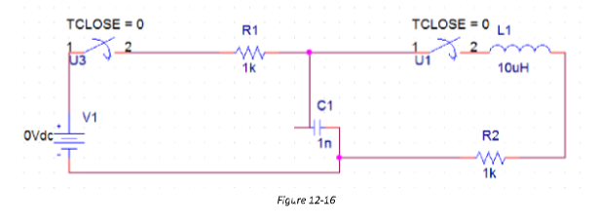

**PSpice Circuit:**

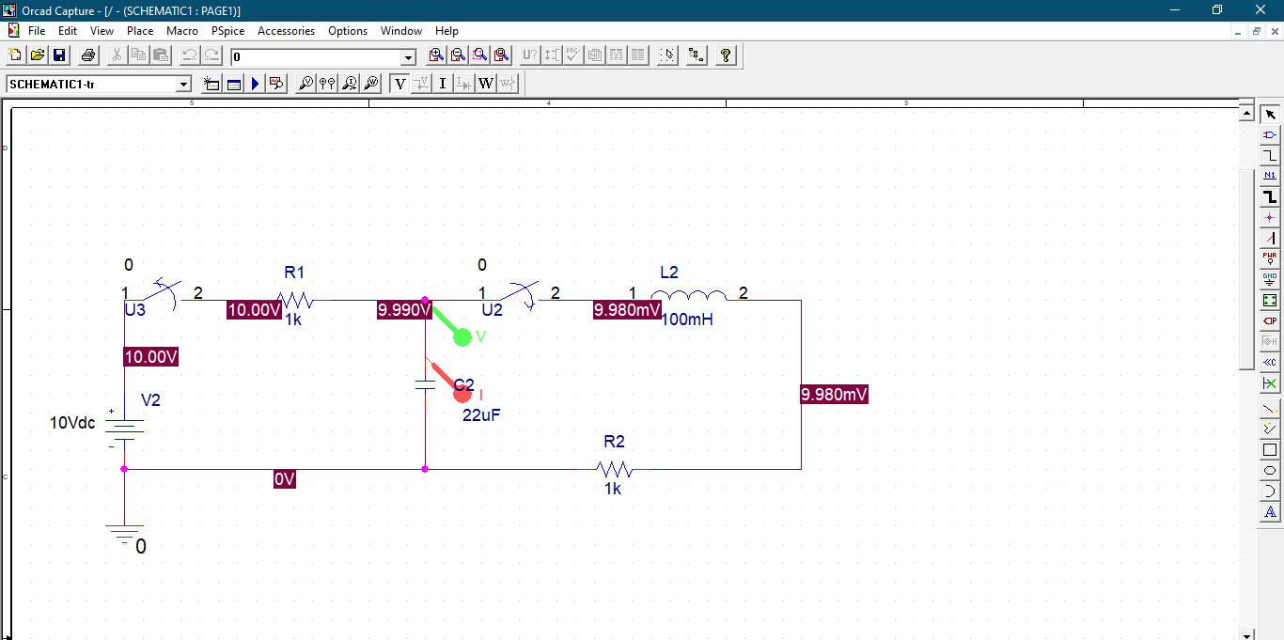

**Simulation Output:**

